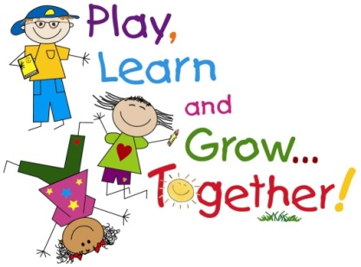

Ms. Erickson and Mrs. Nyhus Kindergarten News

Week of: May 24-28, 2021

Watch Out  
The “almost first graders” are about ready to head out the door and see what being a first grader is all about. The kids are super excited. Watch out first grade… here they come ☺

Reminders/Notes  
Kindergarten Graduation – Thursday, May 27 @ 1:00

Last Day of School – Friday, May 28, Dismissal at 11:30

SCHOOLS OUT FOR THE SUMMER!

Calendar  
Monday: NO SCHOOL

Tuesday: Field Trip – Fawn Doe Rosa

Wednesday: Gym/Music

Thursday: Kindergarten Graduation  
 1:00 in HS Gym

Friday: Early Dismissal – 11:30

Math

The kids have done such a great job with math this year. Many can count all the way to 100 and beyond (WOW) and are getting very good at adding and subtracting. Please continue to work on these skills through the summer. Think of some fun ways to count, write numbers, add and/or subtract – in the car, while eating breakfast, going up the stairs, etc. Doing math can be a lot of fun ☺

Reading

☺ The kids have done such an awesome job with their reading throughout the year. One of our favorite things is to see how much they’ve learned because they are like sponges. Continue to read throughout the summer as much as possible. The library is a great place to get some good books. Thank you for your dedication of reading with your child!